**SC&I Project Schedule**

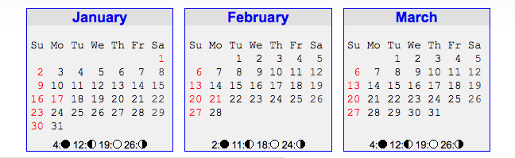

1/13: MOA to SC&I

1/18: SC&I provides IPO

1/18: CS manuscript suggestions/revisions to SC&I

1/20 - 2/11:  Photo shoots as needed

1/20: CS submit proof 1 of folder and mastheads to SC&I

1/25: SC&I provided revised/approved manuscript

1/27: Manuscript to proofreading & fact-checking

1/28: SC&I submit changes to proof 1 of folder and masthead

2/1: CS submit proof 2 for folder and masthead to SC&I

2/4: SC&I approves or submits changes to proof 2

2/4: CS submits proof 1 of brochure to SC&I

2/8: CS submits final proof 3 of folder and masthead to SC&I

2/10: SC&I approves folder and masthead

2/9: SC&I provides changes to proof 1 of the brochure to CS

2/14: CS submits proof 2 of the brochure to SC&I

2/17: SC&I approves/provides changes to proof 2 of brochure

2/22: CS submits final proof 3 of brochure to SC&I

2/25: SC&I approves final proof 3 of brochure/conduct final read

2/28: Release to print

3/3: Review of printer’s proof

3/8: On press

3/14: Delivery