Drupal Platform Themes and Homepage Templates
The following is a list of the theme options and the homepage template options available in the Drupal platform. Using the name conventions below when creating an outline for platform site creation.
For active examples, please visit: http://drupalbasics.rutgers.edu/select-homepage-layout/homepage-layouts-overview or click on one of the images below.

Theme Options
 | THEME | DESCRIPTION
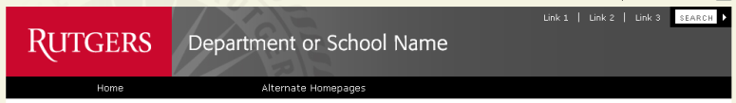 | Red and Gray Split | Banner is red on left, gray on right  Navigation is black
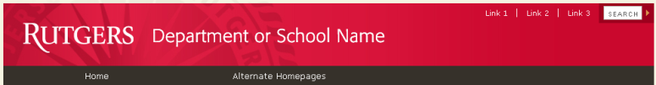 | Red with Dark Gray | Banner is red  Navigation is dark gray
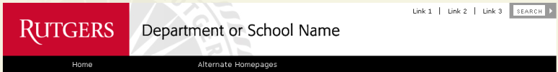 | Red and White Split | Banner is red on left, white on right  Navigation is black
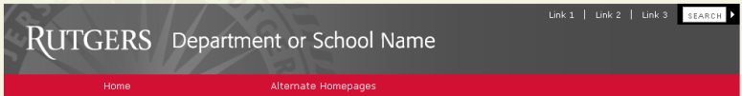 | Gray with Red | Banner is gray  Navigation is red
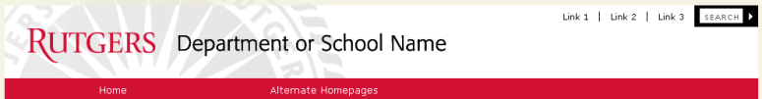 | White with Red | Banner is white  Navigation is red
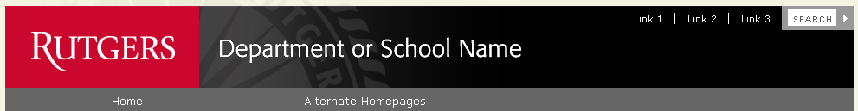 | Red and Black Split | Banner is red on left, black on right  Navigation is gray
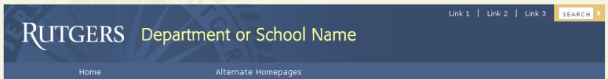 | Blue with Blue | Banner is blue  Navigation is blue
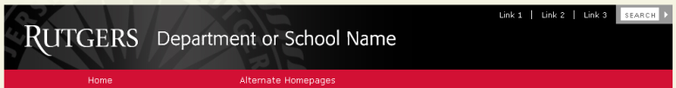 | Black with Red | Banner is black  Navigation is red

Important Note:
If the color of the navigation needs to be adjusted, PLEASE STILL USE ONE OF THE THEME NAMES ABOVE. Then make note of what should be the new color for the navigation.
For example, you would put this in the web plan:
Theme: Red with Dark Gray [Special Note: please use Dark Red navigation]
This format MUST be used because there is no such theme as Red with Dark Red in the Drupal platform system. The lab must manually create and add the CSS for this after the Red with Dark Gray themed site is created.

Homepage Template Options
 | HOMEPAGE TEMPLATE | DESCRIPTION
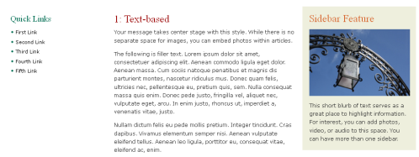 | Text-based | - Quick Links  - Main homepage article  - Home additional feature
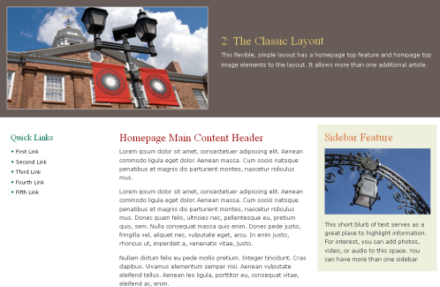 | The Classic | - Homepage top image  - Homepage top feature  - Quick Links  - Main homepage article  - Homepage small feature
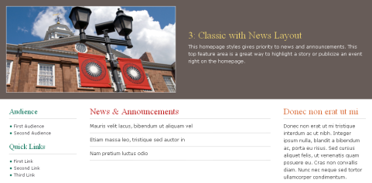 | The Classic with News | - Homepage top image  - Homepage top feature  - Audience navigation menu  - Quick Links  - News items pulled from the news page  - Homepage small feature
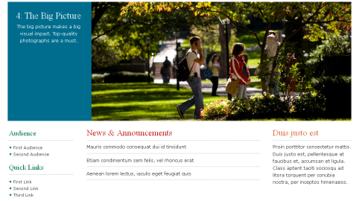 | The Big Picture | - Homepage top feature  - Homepage top image  - Audience navigation menu  - Quick Links  - News items pulled from the news page  - Homepage small feature
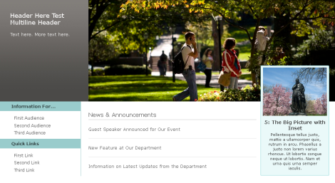 | The Big Picture with Inset | - Homepage top feature  - Homepage top image  - Audience navigation menu  - Quick Links  - News items pulled from the news page  - Homepage small feature
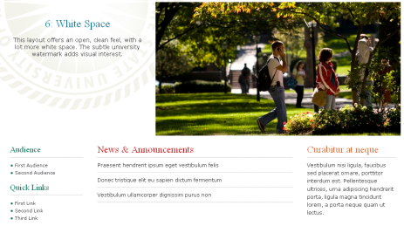 | White Space | - Homepage top feature  - Homepage top image  - Audience navigation menu  - Quick Links  - News items pulled from the news page  - Homepage small feature
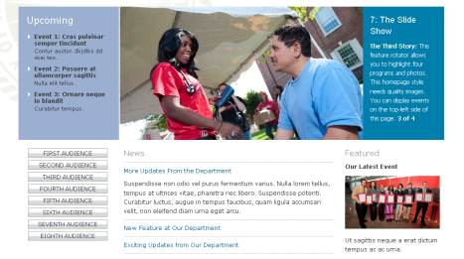 | The Slide Show | - Homepage additional feature  - Homepage top feature (rotates slowly among four features with images)  - Audience navigation menu  - News items pulled from the news page  - Homepage small feature
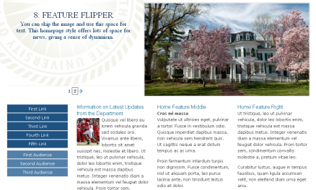 | The Feature Flipper | - Homepage top feature (flips among three stories)  - Homepage image  - Two-colored left navigation menu  - A single news item pulled from the news page  - Homepage features

